ASE PROJECT INCREMENT 3

Lab ID: 6_2

Name: Madhuri Sarda

Name: Udaya Byreddy

Name: Rohitha Goparaju

Name: Sahaja Adavelli

In this Project Increment after capturing a snap the emotion data converted into bar graph and search implementation is also done.

Below is the screenshot for login page of emotion analysis

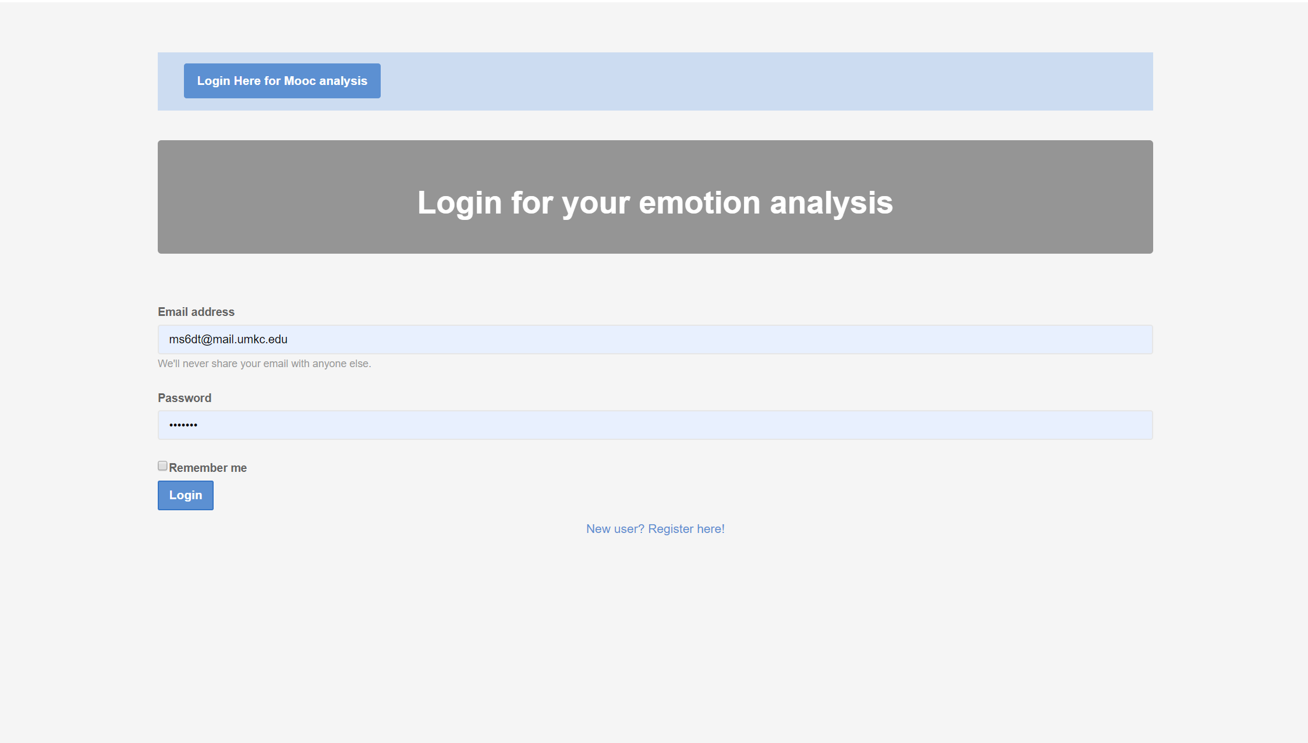

Below image shows the search bar for youtube links. Data will get displayed after searching for any course.

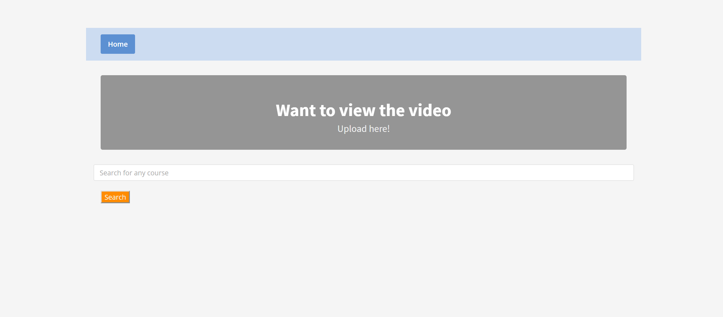

Youtube videos getting displayed after clicking on search button.

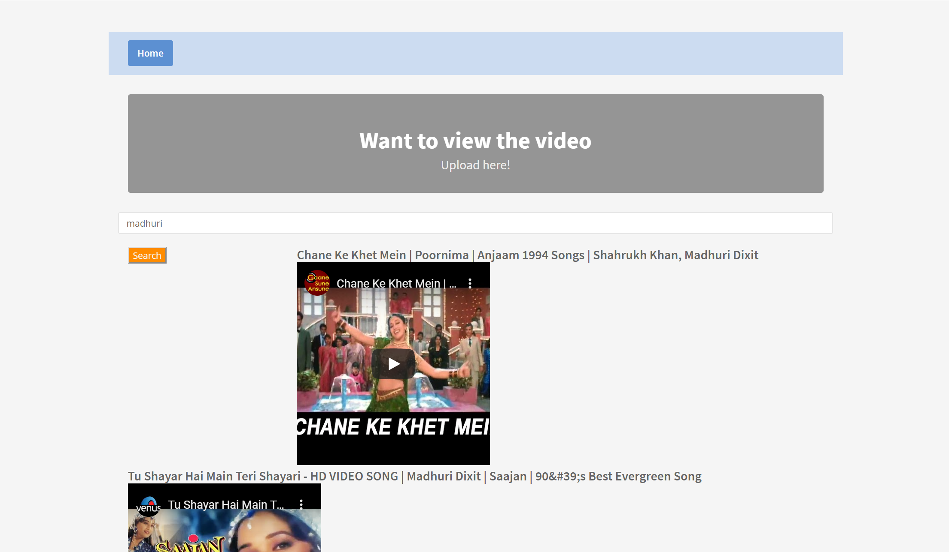

Sample responsive chart for snap captured, it is displayed in the form of a bar graph with angry, contempt, disgust, fear, happiness, neutral, sadness and surprise in percentage format.

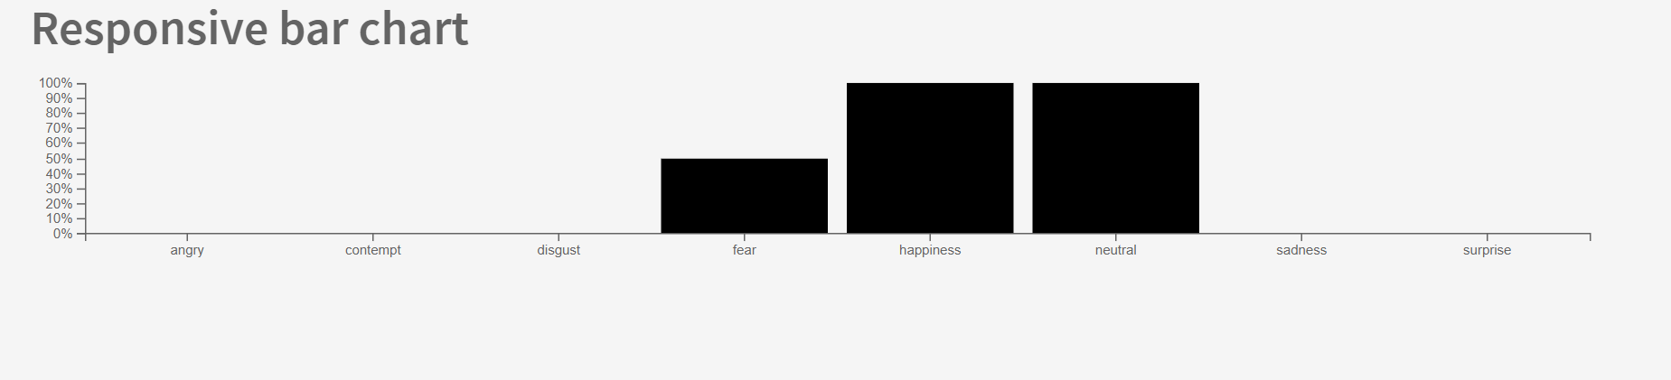

Source code for search button

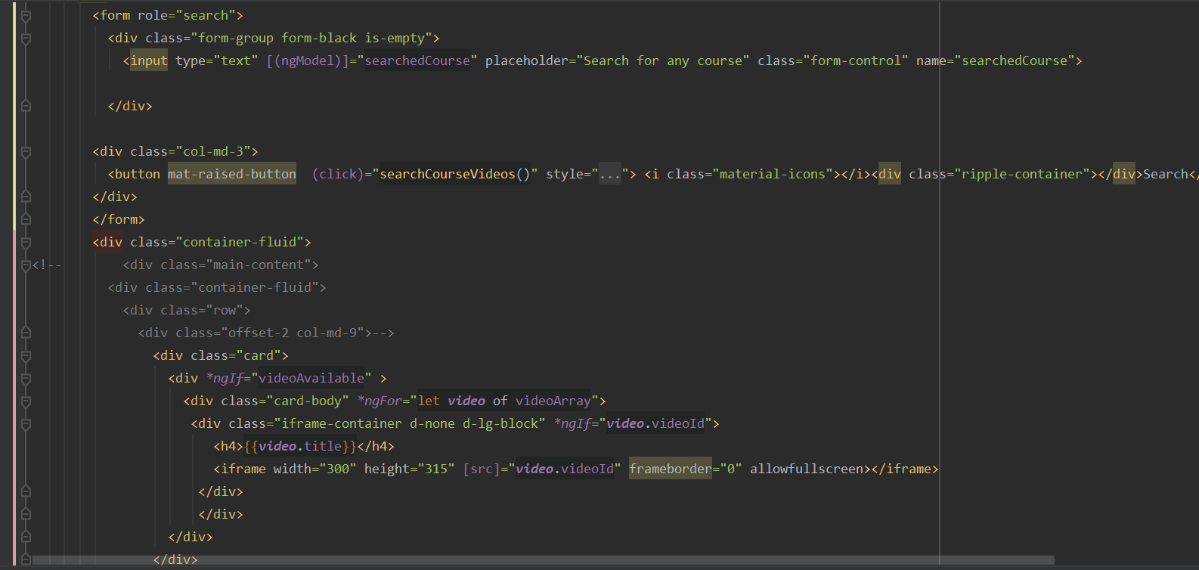

Code for .ts file method call for search button

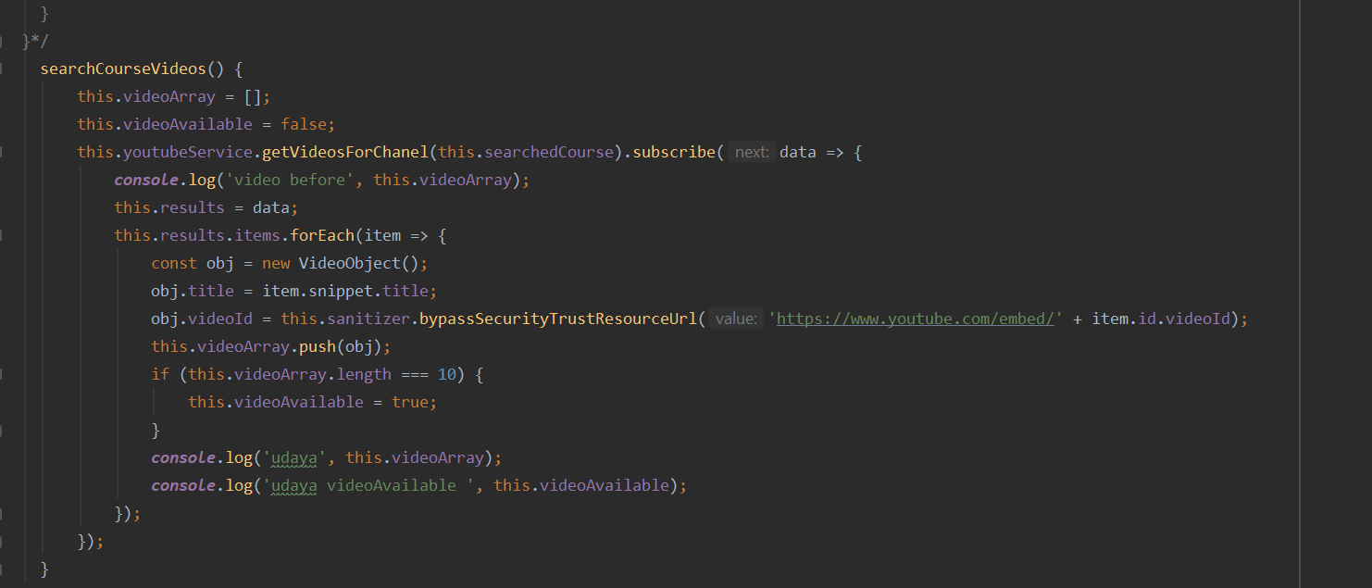

Code snippet for bar graph

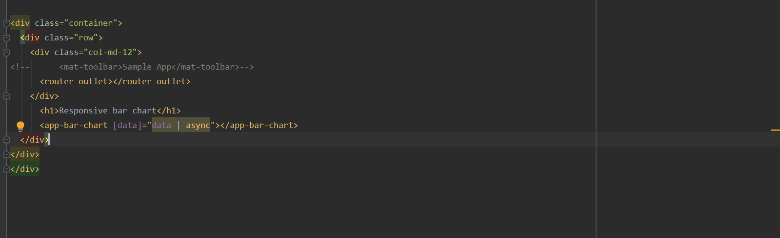

Code snippet for bar graph method

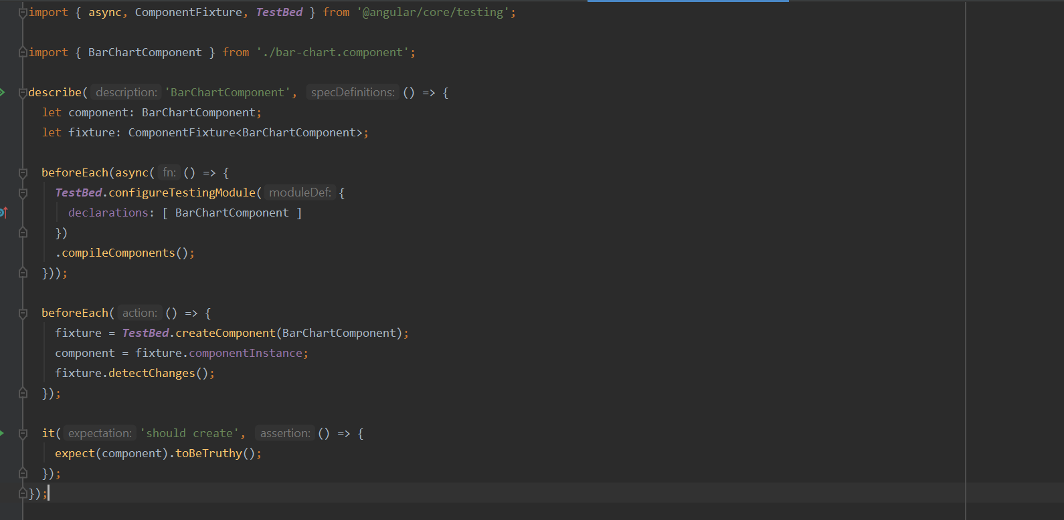

Fire base data

